Task Manager Project Members to Field Task Manager
Object Sequence Diagram
@startuml
Participant “Task Manager” as TM
Participant “Field Task Manager” as FTM
TM -> FTM: AddProjectMembers(TM Project Id, OSM Ids)
FTM -> FTM: Now What?
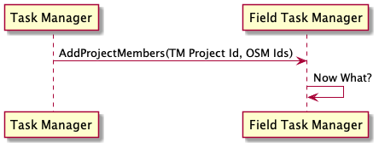
@enduml

